Diary Entry 3 Upgraded Noughts and Crosses

**3.0 Introduction**

The team were required to add additional features to the game of ‘Noughts and Crosses’ to add an element of chance to the game.

3.1 Materials

|  |  |
| --- | --- |
| Material | How the team used it |
| Google Sheets | The team used google sheets to design what the game would look like (Figure 1), and to play test the game (Figure 2). |
| https://freeonlinedice.com/ | The team used this website to emulate a 9-sided dice roll, when doing game testing. |

3.2 The Rules

How the game is played, (pictures) –

The game is a 3X3 noughts and crosses grid, made up of 3X3 noughts and crosses grids. To win the game the player needs to get 3 in a row in the big noughts and crosses grid, and to be able to win the smaller grids the player needs to get 3 in a row the individual smaller grids.

* Both players roll a dice, the player who rolls the higher number gets to start
* Then each player gets to place 2 roll again tiles on any space on the board
* The first player rolls the dice and can then place have their go in the area corresponding to the number on the dice.
* Then the other player has there go, this continues until there is a winner.

3.3 Cards/board/tokens

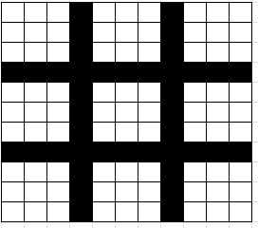

**5**

**6**

**9**

**8**

**7**

**4**

**3**

**2**

**1**

Figure 1 – The Game board - when the player rolls the dice they must make their move in the corresponding small noughts and crosses grid.

**C**

**B**

**A**

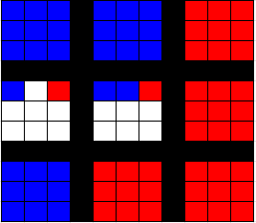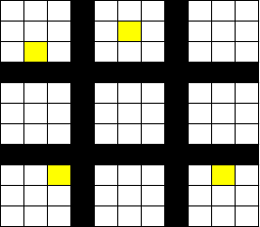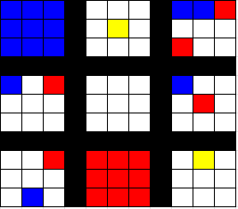

Figure 2 – Pictures of gameplay – [A] is a picture the board with the roll again spaces on it (the yellow squares). [B] is a picture what a game could look like part way through. [C] is a picture of a finished game where the colour red has won.

3.4 Play testing

The team did some internal play testing early in the development, after completing the play testing, we found that the game did not have enough chance, so the team decided to add in a dice roll. This meant that you could only place your colour in the smaller grid that the number indicated rather than anywhere.

The team also did some external play testing, from the play testing an issue came up where if a square was already fully completed and the player rolls that square, do they miss a turn or get to roll again. The team was given mixed reviews on this issue and decided to make it that the player rolls again.

From the playtesting we also got two reviews:

“The game is fun.” – Jamie Smith

“The game feels a bit long, but a good long” - Ali Noorani

This informed the team that external people also enjoyed the game.

3.5 Reflection

Working in a team was slightly harder on this project as there were only two people in the team so there less people to bounce ideas off of so the team could not be as sure if the idea was good until play testing was done. Team communication was much easier as there were only two people and I think this helped the team out a lot.

In the team we did well with playtesting as the game idea was thought of very quickly, this allowed the team to play test a lot internally to try and work out if the mechanics worked. This then also allowed for a slightly more polished game when doing external playtesting. In future projects creating mock-up games quickly will be very beneficial as it allows for more game testing to perfect the game mechanics.

3.6 Design and Play Tester Members

Design Members:

* James Wilson
* Muhammed Zulfqar

External Play Testers:

* Jamie Smith
* Ali Noorani